**MEGAeBin Windows Desktop Build Oct12, 2015**

Home -> Files -> Upload

* When an executable (.exe) file was uploaded, it got uploaded on server, but never got synced on the local system.

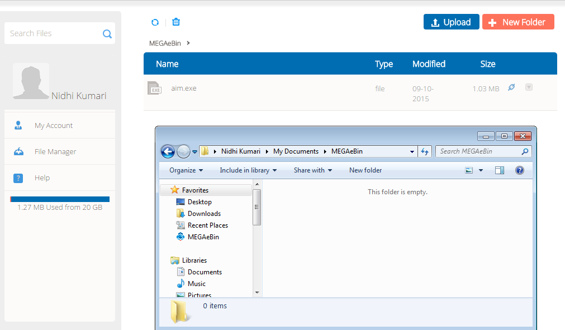

* When a document (.docx) file was uploaded, it got uploaded on server, but never got synced on the local system.

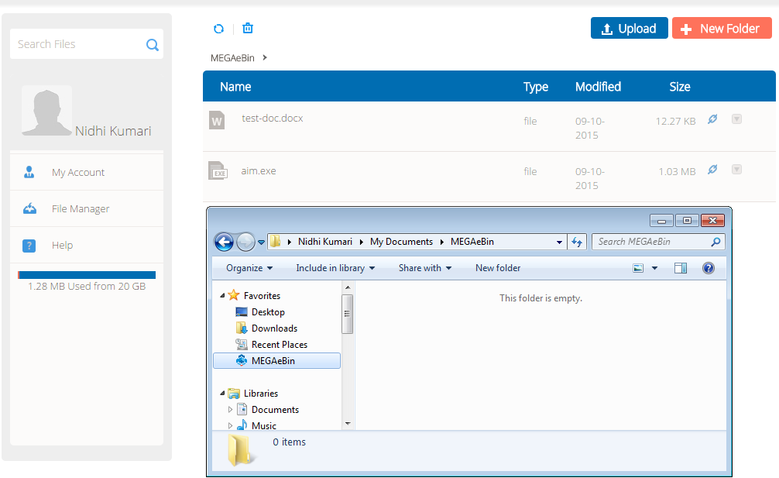

* When an image(.jpg) file was uploaded, it got uploaded on server, but never got synced on the local system.

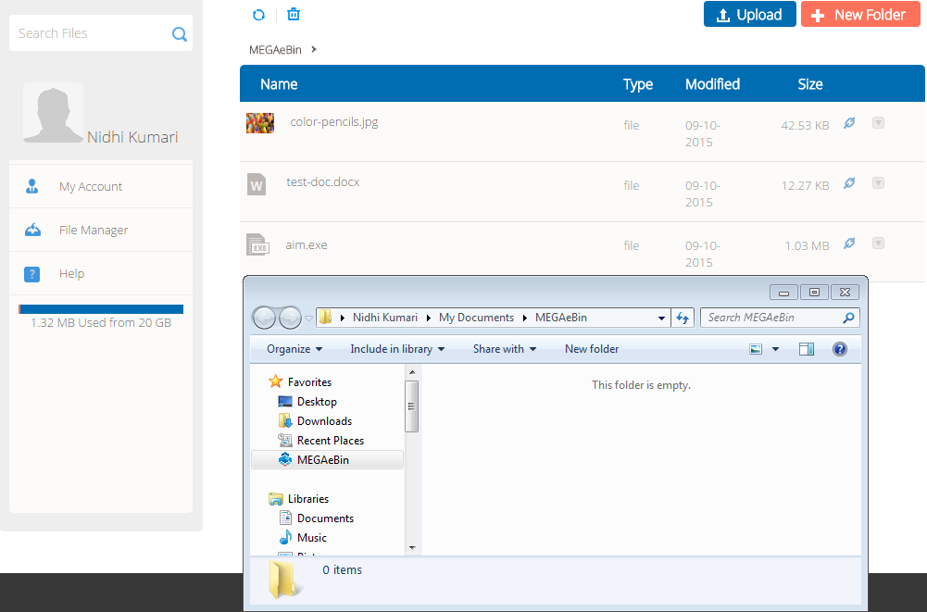

**Dev Comment: We have updated syncing time on Desktop 30 to 5 Second previously it’s was 30 second.**

**VSS-Oct12, 2015: Before it was not synching at all. However, when new build (oct12, 2015) was installed, it is now synching fine.**

**Vstacks-Oct13, 2015: Ok**

**VSS-Oct13, 2015: I don’t know the reason, but it’s not syncing again. I have attached the screenshot below. This blue processing sign is just going on, and so I suppose the app didn’t get started. As you can see below, it says, last update on 2015/10/12. I have the same build installed.**

**(megaebin.com/megaebin-build/MEGAeBin-Windows-Desktop-Build-12-Oct-2015.zip)**

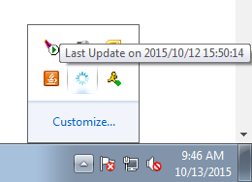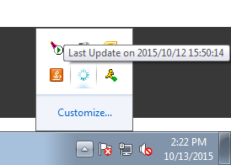

Home -> Events:

* Doesn’t state the event that occurred.

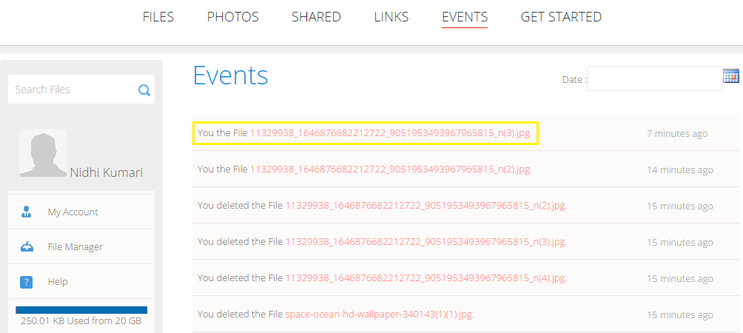

**Dev Comment: Please elaborate about this issue.**

**VSS-Oct12, 2015: What a user can understand by seeing an event like this “You the File some-file-name”? Whether it can be “You deleted the File some-file-name” or “You renamed the File some-file-name” or some event like that.**

**Vstacks-Oct13, 2015: Done**

**VSS-Oct13, 2015: I have one suggestion here. As you can see in screenshot below, we need to modify the event notifications a little. Such as:**

**“You rename the Folder My Images1.” 🡪 “You renamed the folder My Images1.”**

**“You Permanent Delete the File space.jpg.” 🡪 “You permanently deleted the file space.jpg.”**

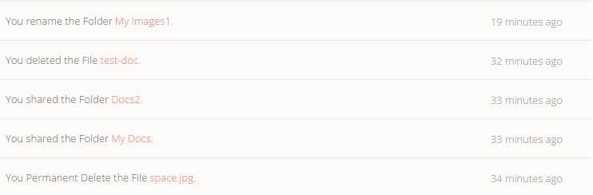

**“You un-favorite the File 1024x600_03.jpg.” 🡪 “You unfavorited the file 1024x600_03.jpg.”**

**“You favorite the File 1024x600_03.jpg.” 🡪 “You favorited the file 1024x600_03.jpg.”**

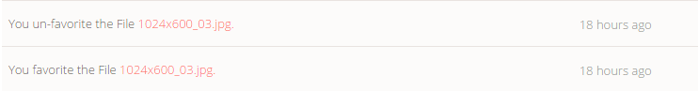

**“You Copy the File Screenshot_2015-10-12-16-12-40.png.” 🡪 “You copied the file Screenshot_2015-10-12-16-12-40.png.”**

**VSS-Oct14, 2015: Updated Content**



* When a file is moved from root folder to another folder, instead of stating event such as “you moved the file file-name from home to folder-name”, it throws added and deleted event. Please refer to the screenshot below.

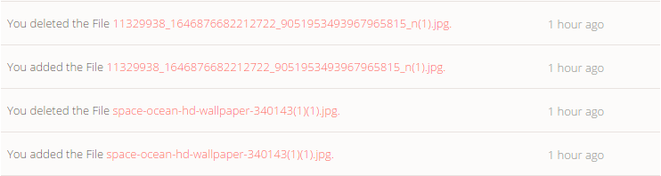

Here, these two files “space-ocean-hd-wallpaper-340143(1)(1).jpg” and “11329938_1646876682212722_9051953493967965815_n(1).jpg” were moved from root folder to a folder My Images1.

Home -> Files -> Show Deleted Items:

* Even though the deleted files/folder shows “No Recover File”, they can still be opened and the content can be seen.

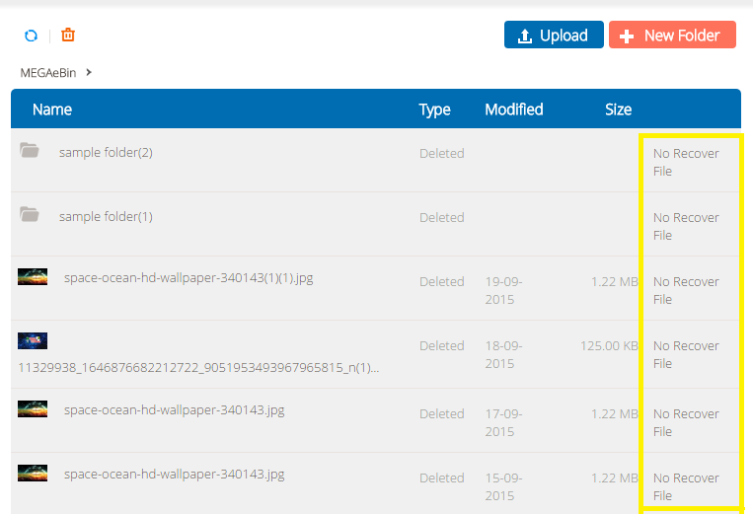

**Dev Comment : We have checked in database and found in your account data Recovery days set as “0” days means you can not restore deleted file /folder. Now we have updated in your account from database recovery days as “30”.   
This recovery time manage from megaebin admin section as per user plan.  
After 30 days you can’t recover Deleted files.**

**VSS-Oct12, 2015: I didn’t mean anything about the Recovery/restoring of the files. My concern was, even though the files say “No Recover File”, I was still able to open and see the content of the “No Recover File”. If the file is “No Recover File”, then a user shouldn’t be able to open the file.**

**Vstacks-Oct13, 2015: Done (now it will show only file/folder name).**

**VSS-Oct13, 2015: I suppose I was not clear before. The file that has already been deleted should not be accessible to the user (user should not be able to open that file, until unless he/she recovers that file. Please refer to the screenshot below.**

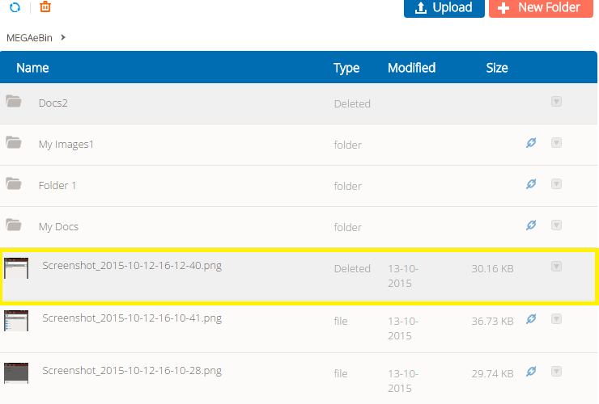

**Say for instance, in the above example, the file “Screenshot_2015-10-12-16-12-40.png” is already deleted, still I was able to access the file (open and see it), without recovering it.**

**VSS-Oct14, 2015: We have updated functionality, but this functionality made as per dropbox reference.**

* Files that aren’t deleted also show up when the option “Show Deleted Items” is selected.

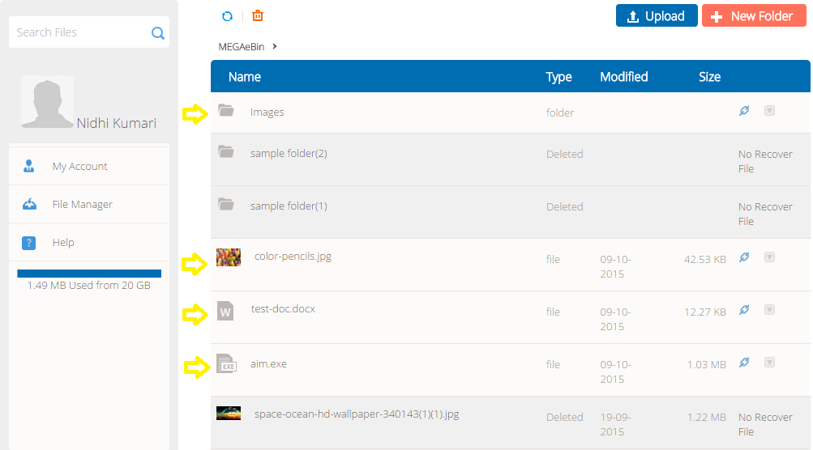

**Dev Comment: this Functionality make as in Dropbox.**

**VSS-Oct12, 2015: “Show Deleted Items” option showing only deleted items seems more appropriate. A user would probably expect the same.**

**Vstacks-Oct13, 2015: Yes we accept your concerns, but we developed this functionality as per dropbox. This is a new change and will take 2 days to implement.**

**VSS-Oct13, 2015: This was just a suggestion, from a user point of view. I am not sure what were the instructions for developing this application or what is the application flow.**

Home -> Files:

* When a document (.docx) file is renamed without extension, it becomes invalid.

When renaming a file, it’s very unlikely for a user to rename a file with extension.

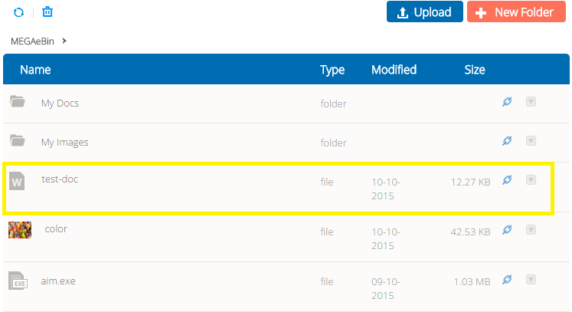

**Dev Comment: If you change file extension then your file will be lost.**

**VSS-Oct12, 2015: I understand that file will be lost, if not renamed with proper extension.**

**But, we can’t expect from every user that they will know every extension or even extension of their own file, they might rename a doc file with pdf extension. A layman is very less likely to rename a file with extension.**

**Say for an instance, when renaming a file on our own desktop, we never put extension with the file name, and that’s how every user renames their file/files.**

**Vstacks-Oct13, 2015: Yes we accept your concerns, but we developed this functionality as per dropbox. This is a new change and will take 1 day to implement.**

**VSS-Oct13, 2015: Again the same. This was just a suggestion, from a user point of view. However, I would favor this change.**

* When selected the option “Create Album” for an existing folder (containing .docx file) under “File” section, instead of throwing prompt “Album couldn’t be created”, it shows “Album created successfully” and then redirects to “Photos” section, where nothing can be seen.

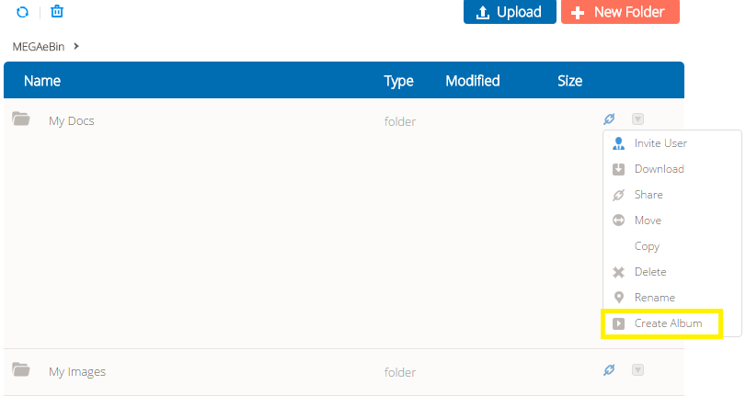

**Dev Comment: We didn’t found this issue.Please elaborate scenario to reproduce this issue.**

**VSS-Oct12, 2015:**

**Scenario: Create a new folder, and put in a .doc file in it. Then, chose the option “Create Album” for the folder. It will say “Album created successfully”, and then you will be redirected to “Albums” section, where you can see nothing.**

**Conclusion: I understand that we can’t create an album out of a .doc file, but then, it shouldn’t throw the message saying “Album created successfully”, when nothing was created.**

**Vstacks-Oct13, 2015: We are unable to reproduce that. When we checked we found that it shows us an alert “There is no image in this folder.” and Album is not created. Please retest the same by clearing your browsers cache and cookies if issue still exist then please provide us the step to reproduce with test account credentials and browser version.**

**VSS-Oct13, 2015:**

**Scenario1: Create a new folder, and put in a .doc (document) file inside it. Then, chose the option “Create Album” for the folder.**

**Result1: Message “Album created successfully”, and then you will be redirected to “Albums” section, where you can see nothing.**

**Scenario2: Create an empty new folder (no files in it). Then, chose the option “Create Album” for the folder.**

**Result2: Message “There is no image in this folder”.**

Under Home -> Files, if selected “move” option for an image file, it doesn’t show “Move to Photos”. So, image files uploaded under “Files” section cannot be moved to “Photos” section.

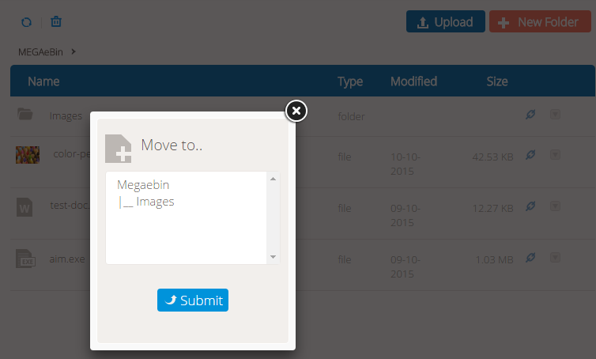

**Vstacks-Oct13, 2015: We can move files/folder in any folder. User can’t move any files in gallery section directly.**

**VSS-Oct13, 2015: Okay.**

* When clicked on “MEGAeBin”, instead of showing only currently existing files, it shows up existing + deleted files.

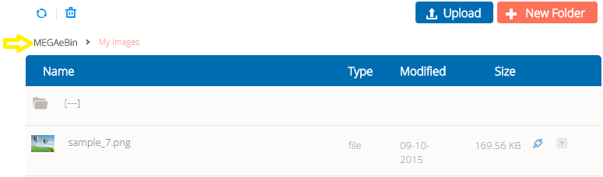

**Dev Comment: If you have clicked on show deleted Icon’s then it will show both files. Otherwise its working fine.**

**VSS-Oct12, 2015: I didn’t click on the “Show Deleted Items” option.**

**Scenario: Select a folder that already has some files in it. I selected a folder named “My Images”, as shown in the above image. When I clicked on the breadcrumb title “MEGAeBin” (pointed by yellow arrow), it showed me all the deleted+existing files. (as shown in image below).**

**Conclusion: Clicking on the breadcrumb title “MEGAeBin” should only show existing files, as it simply means user wants to go back to the existing files.**

**Vstacks-Oct13, 2015: If you do not want to see deleted file you to click on Trash Icon again then it will hide deleted file. If you want to change current flow we have to implement this feature. please confirm?**

**VSS-Oct13, 2015: First thing, I am not talking about trash icon at all.**

**I am talking about the “MEGAeBin” link, if you can see that in the picture above, pointed with yellow arrow.**

**I understand that trash icon hides/shows deleted items. But that’s not my point.**

**Is “MEGAeBin” link supposed to do the same? Show existing+deleted files, when clicked?  
  
Vstacks-Oct14, 2015: Yes**

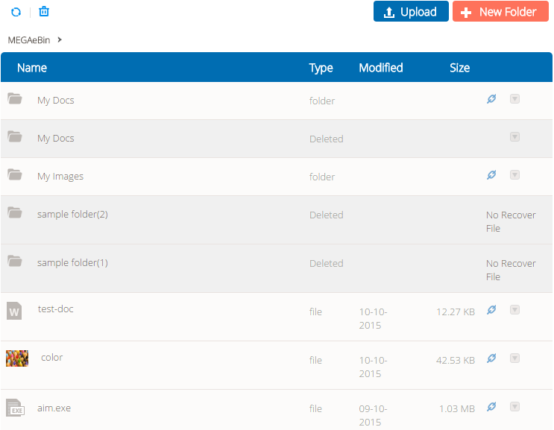

* Selecting “Invite User” option for a folder:

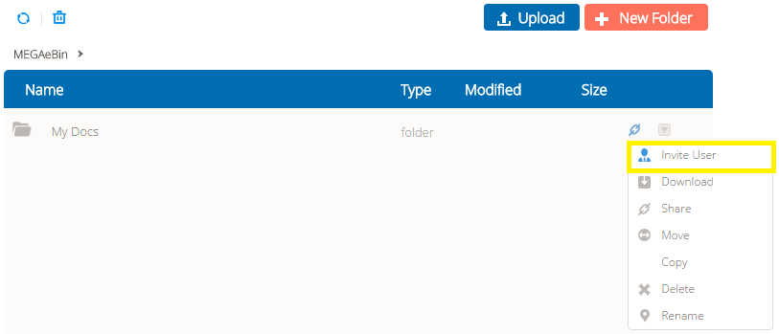

It opens up a window, with no placeholder text or text label. A user probably won’t understand what this is for.

**Dev Comment: Done**

**VSS-Oct12, 2015: It still doesn’t say anything about the text area (no label).**

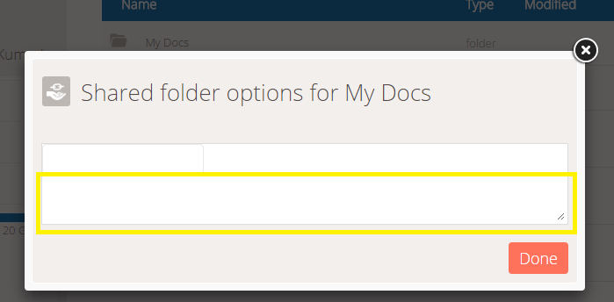

**Vstacks-Oct13, 2015: Kindly clear your browser cache and check it again. At our end it is looks like below screenshot.**

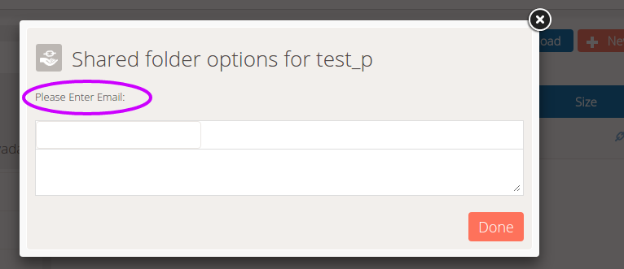

**VSS-Oct13, 2015: Again, I am talking about Text Area here, not Text Box.**

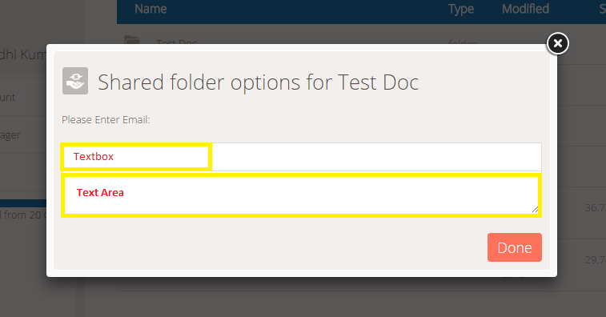

**Vstacks-Oct14, 2015: If you want to show any message to user, please provide us we will update here.**

When a letter, say for instance ‘n’, is entered in the text box, it shows up email of all the MEGAeBin users. A user probably wouldn’t want to see emails of users, he/she doesn’t know about.

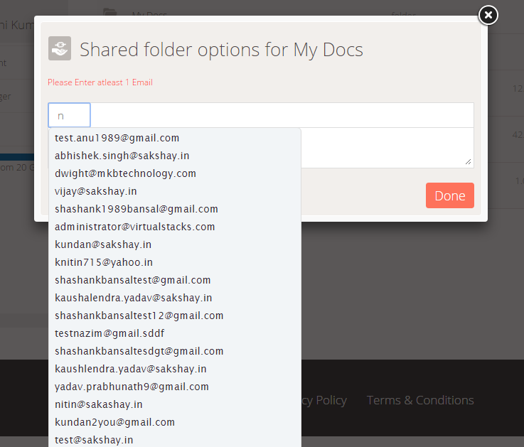

**Dev Comment: Currently we are showing all Megaebin user in suggestion, We can’t show specific users from your circle because we don’t know which user you want to show here.**

**VSS-Oct13, 2015: Okay.**

Home -> Photos:

* There is no option to create an album under “Photos” section, where image files can be moved from “Files” section or uploaded directly.

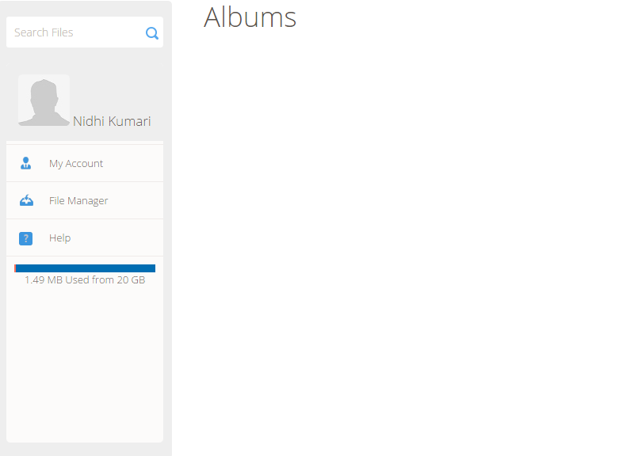

The only way to create an album is by selecting an option “Create Album” for existing folder under “File” section.   
  
**Dev Comment: In photo section we are showing only Albums. You can’t create album here again.**

**VSS-Oct13, 2015: Okay.**

Home -> Shared:

* Even though a folder was shared, it didn’t show up under “Shared” section.

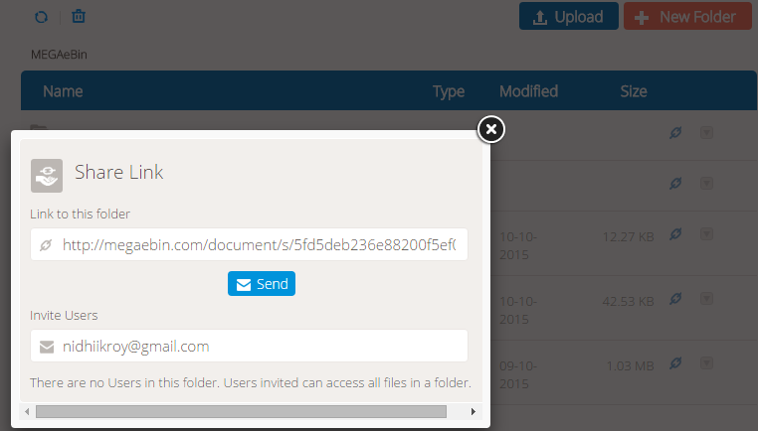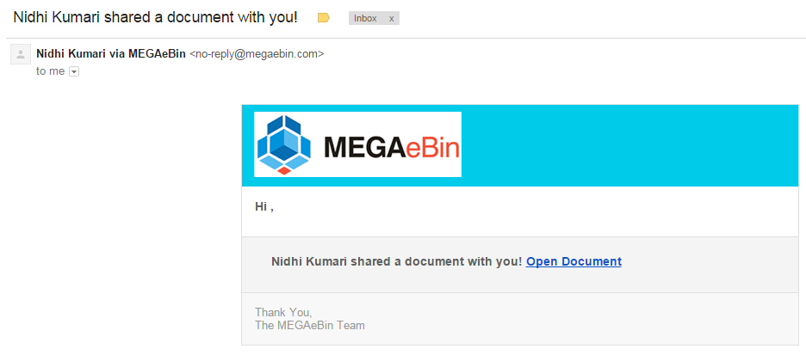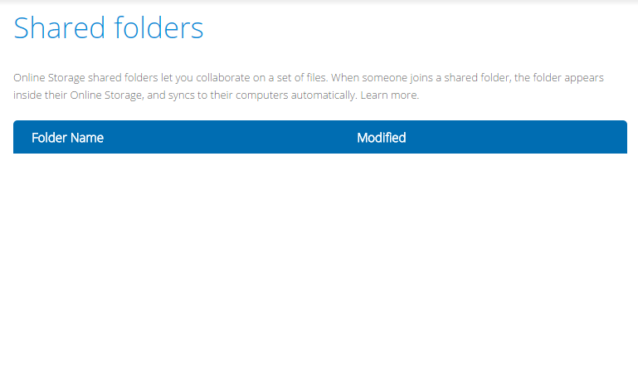

**Dev Comment: In the shared Section will show only those folder which folder you have sent invitation or you accept invitation.**

**VSS-Oct13, 2015: Okay.**